**A**

**PROJECT REPORT**

**ON**

“Predict Blood Donations”

**Submitted as partial fulfillment for the award of**

**BACHELOR OF TECHNOLOGY DEGREE**

Session 2023-24

**In**

**Computer Science and Engineering**

## Submitted by:

Smriti Gupta (2100970100113)

**Under the supervision of :**

**Dr. Aditya Dev Mishra**

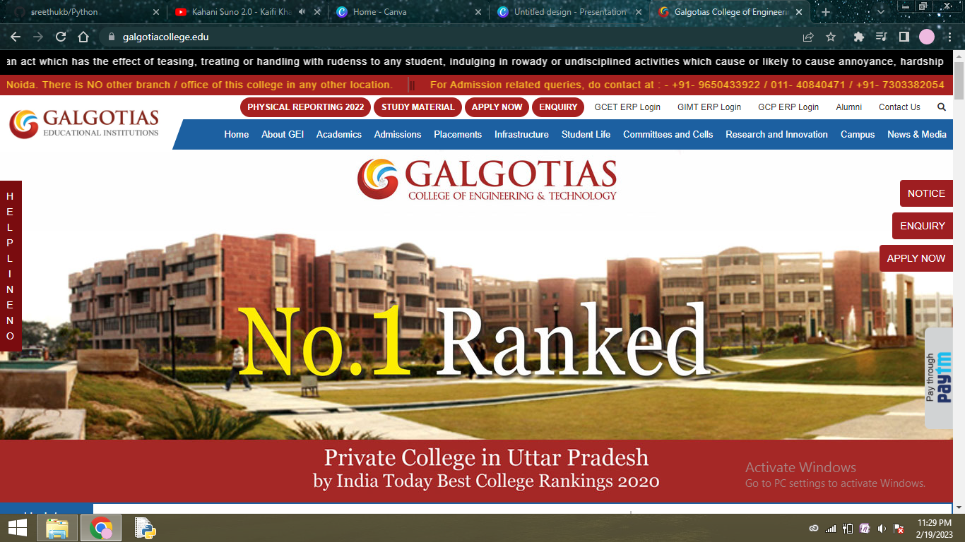

## DEPARTMENT OF COMPUTER SCIENCE AND ENGINEERING

## GALGOTIAS COLLEGE OF ENGINEERING AND TECHNOLGY

GREATER NOIDA



AFFILIATED TO

Dr. A.P.J. ABDUL KALAM TECHNICAL UNIVERSITY

LUCKNOW